SECONDARY MATH 3

**CORE STANDARDS**

F.IF.7b

F.IF.7e

F.BF.3

LESSON

**7-3**

OBJECTIVE **1.** I can identify the key features of graphs.

NOTES

**x intercept:** Where graph touches x axis

**y intercept:** Where graph touches y axis

**Relative maximum:** When a graph goes from increasing to decreasing (high point).

**Relative Minimum:** When a graph goes from decreasing to increasing (low point).

**Interval of Increasing:** Interval where function is rising from left to right.

**Interval of decreasing:** Interval where function is going down from left to right.

**Interval of positive:** Interval where function is above x axis.

**Interval of negative:** Interval where function below as axis.

**End behavior:** Describes what is happening to y values at far left and right of function.

**Domain:** Set of possible inputs for function.

**Range:** Set of possible outputs for functions.

**Symmetry:** Describes if a function has symmetry across the y-axis (even), rotational symmetry about the origin (odd), or neither.

EXAMPLES

1. Graph and analyze the key features of $f\left(x\right)=-x^{3}+2x$.

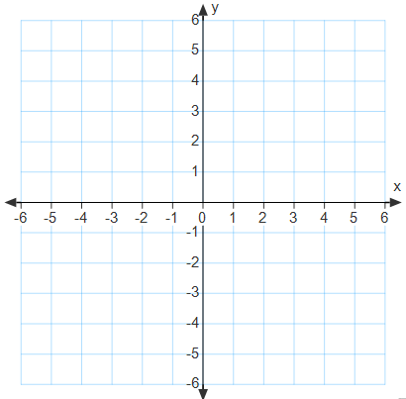

Increasing interval(s)__________

Decreasing interval(s) _________

Positive interval(s) ___________

Negative interval(s) ___________

Relative maximum(s) _________

Relative minimum(s) _________

*x*-intercept(s) ________________

*y*-intercept __________________

End behavior ________________

__________________________

Symmetry __________________

1. Graph and analyze the key features of .



Increasing interval(s)__________

Decreasing interval(s) _________

Positive interval(s) ___________

Negative interval(s) ___________

Relative maximum(s) _________

Relative minimum(s) _________

*x*-intercept(s) ________________

*y*-intercept __________________

End behavior ________________

__________________________

Symmetry __________________

1. Use the characteristics to sketch a graph of the function described.



A square root function has:

Relative maximum (-5,1)

x-intercept (-4,0)

y-intercept (0, -1.236)

End behavior $\lim_{x→∞}{f(x)}=-∞$ and $\lim_{x→-5^{+}}{f\left(x\right)}=1$

1. Use the characteristics to sketch a graph of the funciton described.





A polynomial function has:

Relative maximum (-1,8)

Relative minimum (2,-4)

*x*-intercepts (-2,0), (1,0), and (3,0)

y-intercept (0,6)

End behavior $\lim_{x→∞}{f(x)}=∞$ and $\lim_{x→-∞}{f(x)}=-∞$

PRACTICE **7-3**

1. Graph and analyze the key features of

$f\left(x\right)=\frac{1}{2}\left|x-3\right|-5$.



Increasing interval(s)__________

Decreasing interval(s) _________

Positive interval(s) ___________

Negative interval(s) ___________

Relative maximum(s) _________

Relative minimum(s) _________

*x*-intercept(s) ________________

*y*-intercept __________________

End behavior ________________

__________________________

Symmetry __________________

1. Graph and analyze the key features of .



Increasing interval(s)__________

Decreasing interval(s) _________

Positive interval(s) ___________

Negative interval(s) ___________

Relative maximum(s) _________

Relative minimum(s) _________

*x*-intercept(s) ________________

*y*-intercept __________________

End behavior ________________

__________________________

Symmetry __________________

1. Graph and analyze the key features of



Increasing interval(s)__________

Decreasing interval(s) _________

Positive interval(s) ___________

Negative interval(s) ___________

Relative maximum(s) _________

Relative minimum(s) _________

*x*-intercept(s) ________________

*y*-intercept __________________

End behavior ________________

__________________________

Symmetry __________________

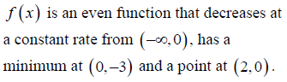

1. Graph



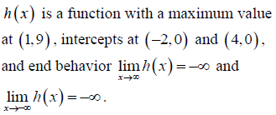

1. Graph.



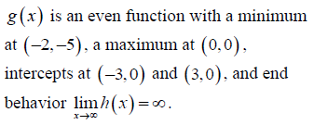

1. Graph.

