SECONDARY MATH 3
CORE STANDARDS
F.IF.7b
F.IF.7e
F.BF.3
LESSON
7-3

OBJECTIVE 1. I can graph parent functions of linear, quadratic, absolute value, cubic, square root, cube root, exponential, logarithmic, and trigonometric functions.
2. I can find function transformations.
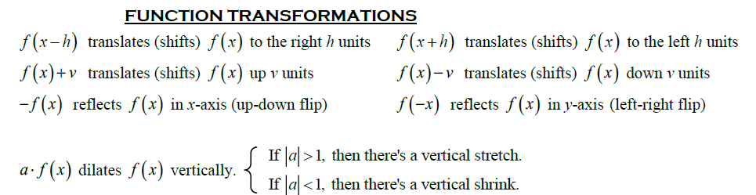
NOTES

Horizontal Shift:

Vertical Shift:

Reflections:
$f\left(bx\right)$; stretches function horizontally by a factor of $\frac{1}{b}$.
$af(x)$; stretched function vertically by a factor of a.

Horizontal Stretch:
$af(x)$; stretches function vertically by a factor of a.

Vertical Stretch:

EXAMPLES
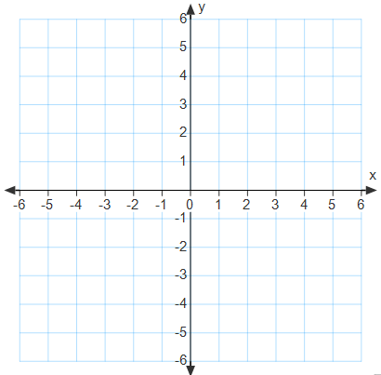

- Given $f(x)$, graph each new function, without technology, and describe the effect of k on the original graph. Is the new function even odd or neither?
$$f\left(x\right)=x^{3}$$
  - $g\left(x\right)=-2f\left(x\right)$
  - $h\left(x\right)=f\left(\frac{1}{3}x\right)$
  - $j\left(x\right)=f\left(x\right)+2$

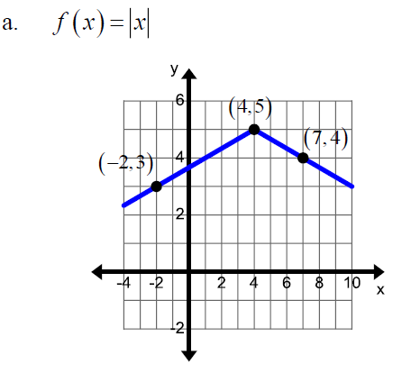
- Determine the transformations that were used to change the given parent function to the function that is graphed, and write the equation of the transformed function.

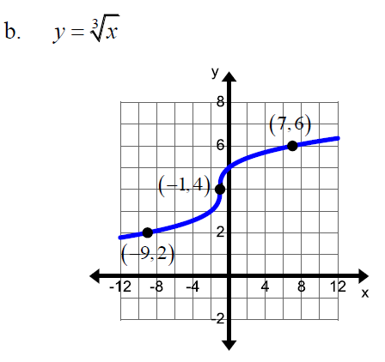

PRACTICE 7-3 NAME______________________________

Given $f(x)$, graph each new function without technology, and describe the transformation on the original graph. Is new the function even odd or neither.

- $f\left(x\right)=x^{2}$
  - $g\left(x\right)=f\left(x+6\right)$
  - $h\left(x\right)=f\left(x\right)+4$
  - $j\left(x\right)=2f(x)$

- $f\left(x\right)=\sqrt{x}$
  - $g\left(x\right)=-3f\left(x\right)+4$
  - $h\left(x\right)=f\left(x-7\right)+2$
  - $j\left(x\right)=4f(x+1)$

- $f\left(x\right)=\log_{3}{x}$
  - $g\left(x\right)=2f\left(-x\right)$
  - $h\left(x\right)=-f\left(x\right)+3$
  - $j\left(x\right)=f\left(x-1\right)-1$
- $f\left(x\right)=\sin{x}$
  - $g\left(x\right)=f\left(2x\right)$
  - $h\left(x\right)=-\frac{3}{2}f\left(x\right)$
  - $j\left(x\right)=f(-x)$

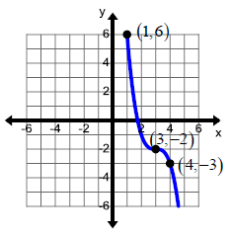
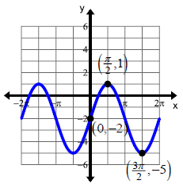
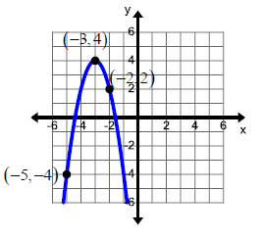
Determine the transformations that were used to change the given parent function to the function that is graphed, and write the equation of the transformed function

5. $f\left(x\right)=x^{2}$ 6. $f\left(x\right)=\sin\left(x\right)$ 7. $f\left(x\right)=x^{3}$

