SECONDARY MATH 3
CORE STANDARDS
A.SSE.4
LESSON
7-1

OBJECTIVE 1. I can evaluate a series with and without technology.

NOTES Sequence: a list of terms where $a_{1}$ and $a_{n}$ is the nth term.
Series: the sum of a sequence.
Geometric series: sum of a sequence $S=a+ar+ar^{2}+…+ar^{n}+…$, where $a$ is the first term and $r$ is the common ratio.
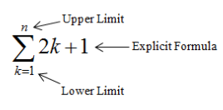

EXAMPLES Write out and evaluate each sum.

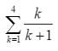
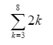
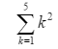
- 2. 3.

4. Use Technology to find the sum of $\sum_{k=5}^{20}{k^{2}+2k}$

5. Write in Sigma notation.

PRACTICE 7-1 NAME______________________________
[SHOW YOUR WORK]
Write out and evaluate each sum.

- $\sum_{k=2}^{6}{\frac{1}{k^{2}}}$

- $\sum_{k=1}^{5}{3k-2}$

- $\sum_{k=1}^{5}{2^{k}-1}$

- $\sum_{k=1}^{4}{{\left(-1\right)}^{k}k}$

- $\sum_{k=3}^{7}{\frac{k}{k+2}}$

- $\sum_{k=1}^{5}{2k+1}$

Write each series using sigma notation.

- $5+7+9+…+17$

- $6+5+4+…+\left(-1\right)$

- $\frac{1}{2}+\frac{1}{4}+\frac{1}{6}+…+\frac{1}{20}$

- $1+4+9+16+…+49$

- $37+34+31+…+13$

- $\frac{3}{4}+\frac{4}{9}+\frac{5}{16}+…+\frac{9}{64}$

- $3+6+9+12+…+384$

