Law of Sines/Cosines
CORE STANDARDS
G.SRT.10
G.SRT.11
LESSON
6-4
Secondary Math 3

OBJECTIVE 1. I can use the Law of Sines and Law of cosines to solve triangles.

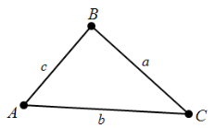
NOTES Law of Sines: For any triangle sine of each angle related to the length of the opposite side.

$\frac{sinA}{a}=\frac{sinB}{b}=\frac{sinC}{c}$ or $\frac{a}{sinA}=\frac{b}{sinB}=\frac{c}{sinC}$
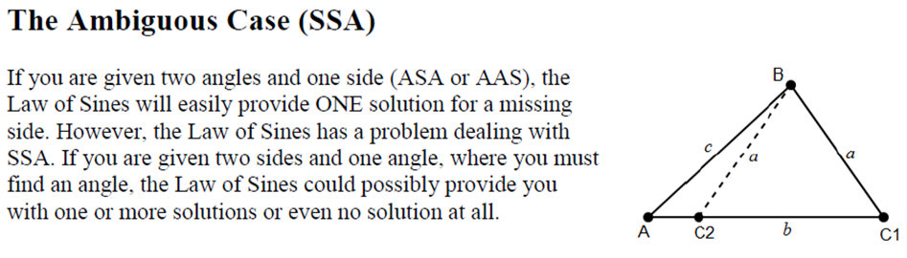

Law of Cosines: For any triangle, the Law of Cosines relates the length of a side to the other sides and the cosine of the included angle.

$$a^{2}=b^{2}+c^{2}-2bc\cos{A}$$
$$b^{2}=a^{2}+c^{2}-2ac\cos{B}$$
$$c^{2}=a^{2}+b^{2}-2ab\cos{C}$$

EXAMPLES
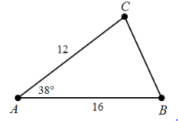
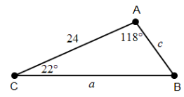
- 4.

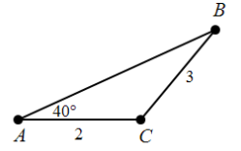
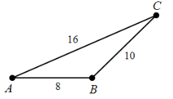
- 5.

- Triangle ABC with sides a = 6, b= 8, and m∠A = 35

PRACTICE 6-3 NAME______________________________
[SHOW YOUR WORK]

