Modeling Periodic Phenomena
CORE STANDARDS
F.TF.7
LESSON
6-2
Secondary Math 3

OBJECTIVE 1. I can utilize inverse trig functions to solve equations.

NOTES Sine and Cosine functions are periodic meaning that more than often there are more than one solution to a problem. We often limit results to $\left[0,2π\right] or \left[0, 360°\right]$
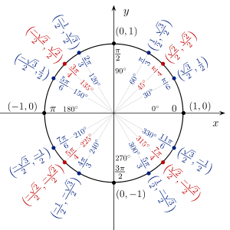
Ex: $\sin{x}=\frac{1}{2}$ when $x=\frac{π}{6},\frac{5π}{6}$, $\cos{x}=-\frac{1}{2}$ when $x=\frac{2π}{3}, \frac{4π}{3}$, and $\tan{x}=-0.79$ when $x=2.473, 5.6146$

When using the $\sin^{-1}{x}$ and $\tan^{-1}{x}$ function, the calculator will give you the angle in the range [-π, π] or [-90$°$, 90$°$]
When using the$\cos^{-1}{x}$ function, the calculator will give you the angle in the range [0, π] or [0,90$°$]

To find second answer for sine subtract first answer from $180° or π$.
To find second answer for cosine subtract first answer from $360° or 2π$.
To find second answer for tangent add $180° or π$ to first answer.
EXAMPLES

- $\cos{x}=0.75$

- $\sin{x}=\frac{\sqrt{3}}{2}$

- $\tan{x}=5$

- $2\sin{x}-1=0$

- $4\cos{x}=-3$

- $\tan{x}+4=3$

- $\sin{x}\cos{x}-3\cos{x}=0$

- A heater turns on in a home when the outside temperature is below 45°F . During the middle of March in Salt Lake City, you can model the outside temperature in degrees Fahrenheit using the function $\left(t\right)=43+9.5\cos\left(\frac{π}{12}t\right)$, where t is the number of hours past noon. During which hours is the heater heating the home?

PRACTICE 6-2 NAME______________________________
[SHOW YOUR WORK]

