Modeling Periodic Phenomena
CORE STANDARDS
F.TF.2
F.TF.5

LESSON
6-1
Secondary Math 3

OBJECTIVE 1. I can model periodic event using trigonometry.

NOTES Typically when working with trigonometric functions we work in radians.
Phase Shift-
$f\left(x\right)=a\sin\left(b(x-h)\right)+k$ and $f\left(x\right)=a\cos{(b(x-h))}+k$
Where h is the phase shift (horizontal shift) of the function.
Models of periodic events.
Many events in the world are periodic in nature, such as:
- Tides
- Biorythms
- Sound waves
- Length of the day
- Average temperature
- Height of a person on a Ferris Wheel.
- And more.

EXAMPLES
- Identify the amplitude, period, and phase shift, then sketch one period of the graph.
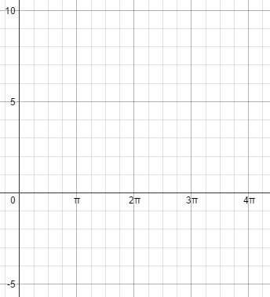
  - $f\left(x\right)=2\cos{(2(x-\frac{π}{4}))}+3$ b. $f\left(x\right)=\cos\left(\frac{1}{3}x-\frac{2π}{3}\right)+2$

- The Ferris wheel at Lagoon has a diameter of 21.8 meters. It rotates on a platform that is 3 meters above the ground. The Ferris wheel completes one revolution in 40 seconds. Write an equation to model the situation. Then sketch a graph of height versus time, extending the graph for more than one revolution.

- In Salt Lake City, Utah, at the spring equinox (March 20, 2013) there were 12 hours and 9 minutes of daylight. The longest day (June 20, 2013) and shortest day (December 21, 2013) of the year vary from the equinox by approximately 3 hours. Write a sine function that relates the number of days to the variation of daylight hours in Salt Lake City. Graph the model, showing at least one year.

PRACTICE 6-1 NAME______________________________
[SHOW YOUR WORK]

Identify the amplitude, period, and phase shift, then sketch one period of the graph.
- $f\left(x\right)=\sin\left(x-\frac{π}{2}\right)+2$
- $f\left(x\right)=-2\sin\left(x-π\right)$
- $f\left(x\right)=3\sin\left[2\left(x-\frac{3π}{2}\right)\right]+1$

- A buoy oscillates up and down as waves go past. The buoy moves a total of 3.6 feet from its low point to its high point, and then returns to its high point every 8 seconds. Write a cosine function modeling the buoy’s vertical position at any time t.

- A Ferris wheel 50 feet in diameter makes one revolution every 40 seconds. The center of the wheel is 30 feet above the ground. Write a cosine function to model the height of a car on the Ferris wheel at any time t.

- Low tide is at 10:15 am and high tide is at 4:15 pm. The water level varies 64 inches between low and high tide. Write a cosine function to represent the change in water level.

- The lowest pitch a human can easily hear has a frequency of 30 cycles per second. Write a sine function representing the sound wave of the pitch. (Amplitude is 1)

- The highest pitch a human can easily hear has a frequency of 20,000 cycles per second. Write a sine function representing the sound wave of the pitch. (Amplitude is 1)

- In Buenos Aires, Argentina, the average monthly temperature is the highest in January and the lowest in July. It ranges from 76°F to 51°F. Write a cosine function that models the change in temperature according to the month of the year.

