SM3 Radical and Absolute Graphs
CORE STANDARDS
A.REI.2
LESSON
3-3

OBJECTIVE 1. I can graph absolute value and radical functions.

NOTES Parent Functions:

Absolute Value: Square Root: Cubic Root:
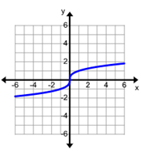
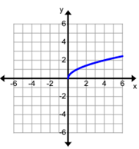
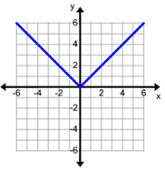

$f\left(x\right)=a\left|x-h\right|+k$ $f\left(x\right)=a\sqrt{x-h}+k$ $f\left(x\right)=a\sqrt[3]{x-h}+k$

Vertex is $(h,k)$
To graph: determine the vertex then determine the slope. Please note that this is symmetrical across line $x=h$.
Starting point is at $(h,k)$
To graph: Determine the starting point and find the appropriate arc.

Center point at $(h,k)$
To graph: Determine the center and find surrounding points. Please note the rotational symmetry

EXAMPLES

1. $f\left(x\right)=-2\left|x-3\right|+5$ 2. $f\left(x\right)=\sqrt{-(x+3)}-2$ 3. $f\left(x\right)=-\sqrt[3]{x-4}+1$
