SECONDARY MATH 3
CORE STANDARDS
A.APR.3
F.IF.7c

LESSON
2-4

OBJECTIVE 1. I can graph polynomials using technology and by hand.
2. I can determine if a polynomial has multiple zeros and predict the reaction of the graph.

NOTES Multiplicity of Zeros: The Fundamental Theorem of Algebra states that zeros can be repeated. When this is the case the same factor occurs multiple times.We say that the factor has a multiplicity of the number of time it is repeated.

${\left(x-5\right)}^{4}$has a zero at $(5,0)$ and is repeated 4 times so it has a multiplicity of 4. If a repeated zero has a multiplicity that is even its graph will touch that point and return the other direction. If it is odd then the graph will pass all the way through that point.

EXAMPLES

- Use technology to graph, identify the zeros, their multiplicity, and determine whether they touch or cross.
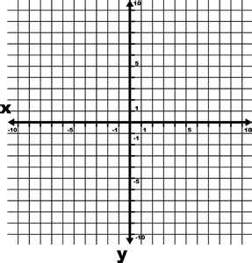
  - $f\left(x\right)={\left(x-4\right)}^{2}{\left(x-1\right)}^{3}$ b. $f\left(x\right)={\left(x-1\right)}^{2}\left(x+2\right)$

- Without using technology sketch each polynomial.
  - $f\left(x\right)={\left(x+3\right)}^{2}\left(x-1\right)$ b. $f\left(x\right)=-x{\left(x+5\right)}^{4}{\left(x-2\right)}^{3}$

PRACTICE 2-4 NAME______________________________
[SHOW YOUR WORK]
Use technology to graph the polynomial. Identify the zeros, their multiplicity, and determine whether they touch or cross the x axis.

- $f\left(x\right)={\left(x+1\right)}^{4}{\left(x-5\right)}^{3}$

- $f\left(x\right)={\left(x-2\right)}^{2}{\left(x+3\right)}^{2}\left(x-4\right)$
- $f\left(x\right)={\left(x-4\right)}^{2}{\left(x+1\right)}^{3}\left(x+3\right)$

- $f\left(x\right)={\left(x-2\right)}^{3}{\left(x+1\right)}^{2}{\left(x-5\right)}^{2}$

Without technology, sketch each polynomial

- $f\left(x\right)={\left(x-4\right)}^{2}\left(x+2\right)$

- $f\left(x\right)={\left(x-3\right)}^{2}{\left(x+5\right)}^{3}\left(x-1\right)$

- $f\left(x\right)={\left(x+2\right)}^{4}{\left(x-1\right)}^{5}$

- $f\left(x\right)=-{\left(x-4\right)}^{3}{\left(x+1\right)}^{2}$

