SECONDARY MATH 3
CORE STANDARDS
A.APR.3
F.IF.7c

LESSON
2-3

OBJECTIVE 1. I can graph polynomials using technology and by hand.

NOTES End Behavior: Refers to the nature of the graph as x approaches positive and negative infinity.

With polynomials, the degree and lead coefficient determine the end behavior.
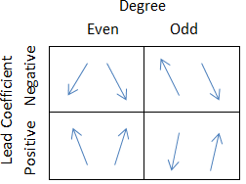
Fundamental Theorem of Algebra:
A polynomial of degree n has exactly n complex zeros (some may be repeated zeros).

EXAMPLES Determine the zero values and end behavior, then graph the function.

- $f\left(x\right)=x^{2}-x-20$ 2. $f\left(x\right)=-x^{3}+2x^{2}+5x-6$
$f\left(x\right)=\left(x-4\right)\left(x+5\right)$ $f\left(x\right)=-\left(x-3\right)\left(x+2\right)\left(x-1\right)$
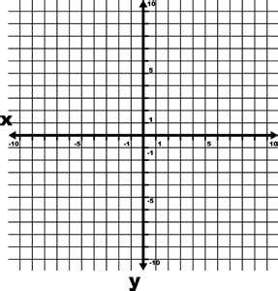

3. $f\left(x\right)=-x^{4}+x^{3}+11x^{2}-9x-18$ 4. $f\left(x\right)=x^{5}+3x^{4}-20x^{3}-60x^{2}+64x+192$ $f\left(x\right)=-\left(x^{2}-9\right)\left(x+1\right)\left(x+5\right)$ $f\left(x\right)=\left(x^{2}-4\right)\left(x+3\right)\left(x-4\right)\left(x+4\right)$

5. Determine the number of zeros each of the polynomials has.
  - $f\left(x\right)=3x^{3}+2x^{2}-7x+2$ b. $g\left(x\right)=100+x^{4}-29x^{2}$

PRACTICE 2-3 NAME______________________________
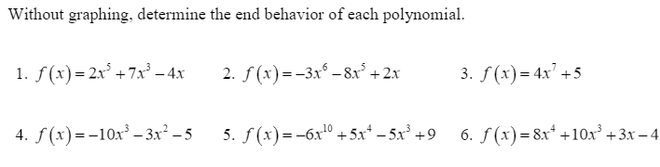
[SHOW YOUR WORK]
Then determine the number of zeros for each.

Graph the polynomial and identify zeros and end behavior.
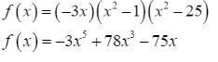
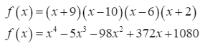
- 8.

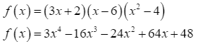
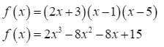
- 10.

