Geometry: 2D and 3D
CORE STANDARDS
G.GMD.4

LESSON
10-1
Secondary Math 3

OBJECTIVE 1. I can describe the shape created by slicing a 3 dimensional shape.
2. I can describe the shape created by rotation a 2 dimensional shape.

NOTES Slicing:
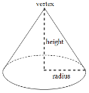
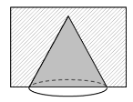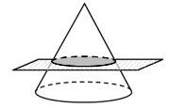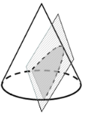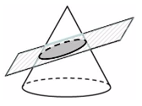
- Create a cylinder
  - What shape do you get slicing it vertically?
  - What shape do you get slicing it horizontally?
  - How would you slice the cylinder to get a parabola?

- Create a square-based pyramid
  - How would you slice it to get a square?
  - What shape do you get slicing it diagonally?
  - Can you slice a square-based pyramid to get a pentagon?

Rotating:

- Rotate around x-axis 4. Rotate around y-axis 5. Rotate around x-axis
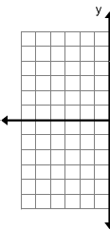
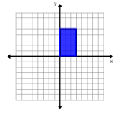
PRACTICE 10-1 NAME______________________________
[SHOW YOUR WORK]

Determine the two-dimensional cross-section that is created from each slice described.

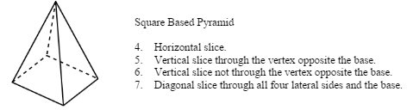
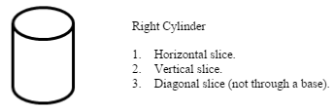

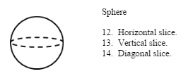
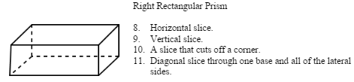

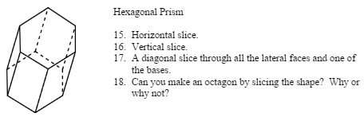

Sketch the result of rotating each shape around the given axis

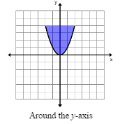
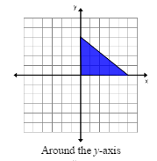
19. 20. 21.
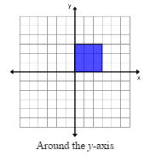
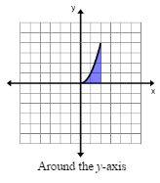
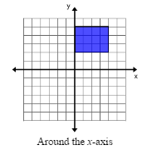
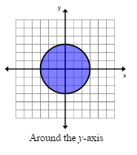
22. 24. 25.

