SECONDARY MATH 3
CORE STANDARDS
A.APR.5
LESSON
1-4

OBJECTIVE 1. I can expand binomials.

NOTES Binomial Theorem: For any positive integer n,
${\left(a+b\right)}^{n}=\left(\begin{aligned}n \\ 0\end{aligned}\right)a^{n}+\left(\begin{aligned}n \\ 1\end{aligned}\right)a^{n-1}b+…+\left(\begin{aligned}n \\ r\end{aligned}\right)a^{n-r}b^{r}+…+\left(\begin{aligned}n \\ n\end{aligned}\right)b^{n}$ , where $\left(\begin{aligned}n \\ r\end{aligned}\right)= _{n}C_{r}$.
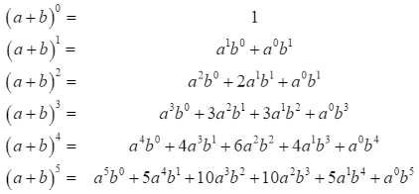
Pascal’s Triangle can also be used to determine the coefficient.

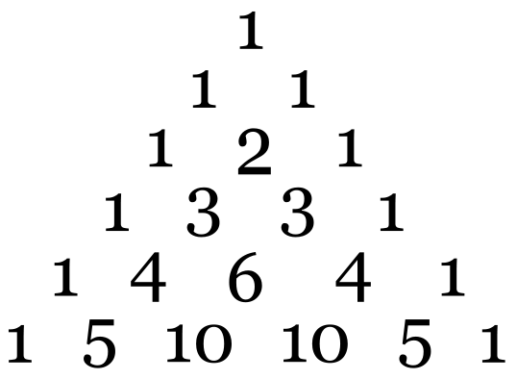

EXAMPLES Expand

- ${\left(2x+4\right)}^{3}$

- ${\left(3x-2y\right)}^{5}$

PRACTICE 1-4 NAME______________________________
[SHOW YOUR WORK]
Expand the following:
- ${\left(x+3\right)}^{6}$

- ${\left(x-2\right)}^{7}$

- ${\left(2x-1\right)}^{5}$

- ${\left(5x+y\right)}^{6}$

- ${\left(4x-3y\right)}^{5}$

- ${\left(3x+2y\right)}^{4}$

