PRACTICE **1-1** NAME______________________________

[SHOW YOUR WORK] [WRITE ALL ANSWERS IN SIMPLIFIED FORM]

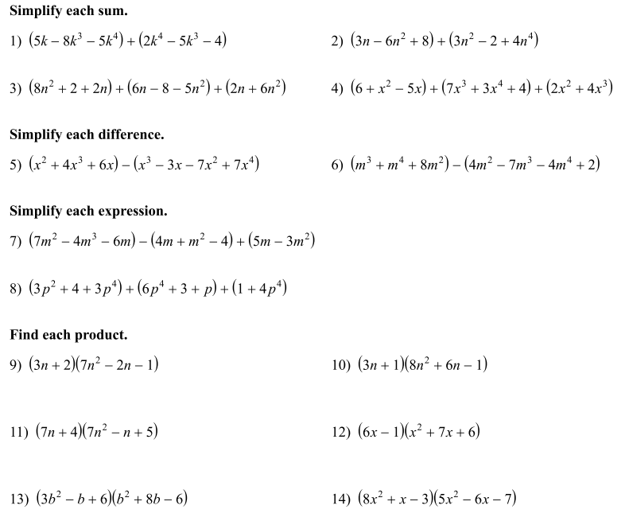

$$40x^{4}-43x^{3}-77x^{2}+11x+21$$

$$3b^{4}+23b^{3}-20b^{2}+54b-36$$

$$6x^{3}+41x^{2}+29x-6$$

$$21n^{3}+8n^{2}-7n-2$$

$$49n^{3}+21n^{2}+31n+20$$

$$24n^{3}+26n^{2}+3n-1$$

$$13p^{4}+3p^{2}+p+8$$

$$-4m^{3}+3m^{2}-5m+4$$

$$5m^{4}+8m^{3}+4m^{2}-2$$

$$-7x^{4}+3x^{3}+8x^{2}+9x$$

$$3x^{4}+11x^{3}+3x^{2}-5x+10$$

$$9n^{2}+10n-6$$

$$4n^{4}-3n^{2}+3n+6$$

$$-3k^{4}-13k^{3}+5k-4$$

1. Find the perimeter and area of the rectangle shown below in terms of *x*.

Perimeter = $2x^{2}+8x+4$

$$2x+3$$

Area = $2x^{3}+7x^{2}+4x-3$

${ x}^{2}+2x-1$

$$5$$

1. Refer to your answer for #13 above. A) How many terms does it have?

$$4$$

B) What is the degree of the polynomial?

$$23$$

C) What is the coefficient of the 2nd term?

1. Simplify.

$$-8x^{3}-7x^{2}+16x-16$$

 