SECONDARY MATH 3
CORE STANDARDS
A.APR.1

LESSON
1-1

OBJECTIVE 1. SWBAT add, subtract, & multiply polynomial expressions.
Like Terms: terms that have identical variable parts. Like terms can be combined by adding coefficients. The variable part remains the same when combining.
Terms: any numbers and/or variable(s) multiplied together. Terms are separated by plus and minus signs. There are 4 terms in this example. Can you circle them?
NOTES Polynomials 101
Degree of a Term: the total of all the exponents of the variables in a term. If no exponent is written, assume 1. If a term has no variables, it is called a constant term and has a degree of zero. Identify the degree of each term in the example.

Example:
Variable: the “letter” part of a term. Some terms have many variables, while others have none.
Coefficient: the number part of a term. If no number is written, assume 1. The sign in front of the term is the sign of the coefficient. Name the example’s coefficients.
Degree of a Polynomial: the highest degree of any term, given that the polynomial is in simplified form. What is the degree of the example?

Simplified Form: a polynomial written as the sum of terms where no terms are like and the degrees of the terms are in descending order. If degrees are the same, then order those alphabetically by variable. You should also know that the exponents of variables must be non-negative integers in order to be classified as a polynomial.

EXAMPLES Write all answers in simplified form.

1. Add. $\left(2x^{3}-3x^{2}+4x-1\right)+(x^{3}+x^{2}-5x+3)$ 2. Subtract. $\left(4x^{2}+3x-4\right)-(2x^{3}+x^{2}-x+2)$

3. Multiply. $(2x+3)(6x^{2}-7x-5)$ 4. Multiply. $(2x^{2}+3x-1)(6x^{2}-7x-5)$

5. Simplify. $4x^{2}\left(3x^{3}-4x+5\right)-\left(2x+8\right)+x^{3}(x^{4}+x)$

Please note that the set of all polynomials is closed for addition, subtraction, and multiplication. That is, if you add, subtract, or multiply 2 polynomials, then the answer is also a polynomial.
PRACTICE 1-1 NAME______________________________
[SHOW YOUR WORK] [WRITE ALL ANSWERS IN SIMPLIFIED FORM]
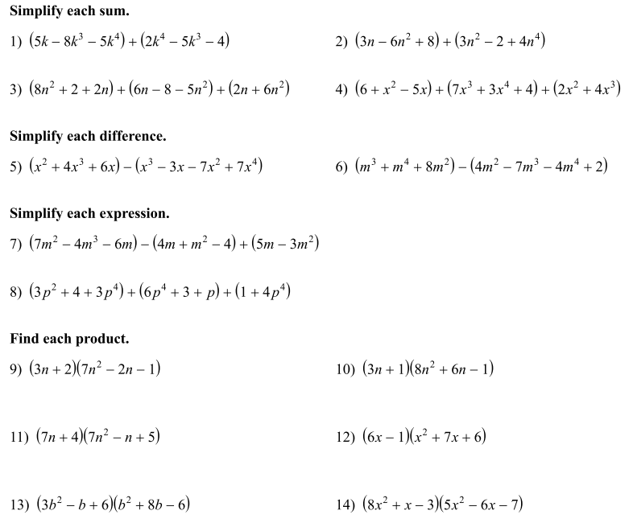

- Find the perimeter and area of the rectangle shown below in terms of x.

$$2x+3$$

${ x}^{2}+2x-1$
- Refer to your answer for #13 above. A) How many terms does it have?
B) What is the degree of the polynomial?
C) What is the coefficient of the 2nd term?

- Simplify.

