Name ______________________________________________ SM2 Unit 6 Practice Test

Refer to circle A below to answer the following questions (1-5).  is a tangent, and  and  are secants. The figure is not drawn to scale.

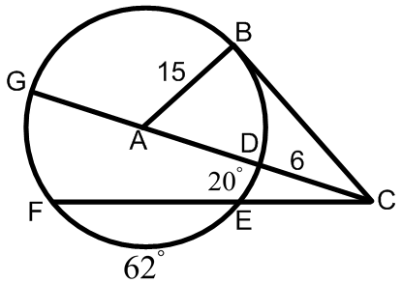

1. What is ? 2. What is ?

3. What is ? 4. What is ?

Refer to circle A below to answer the following questions (5-7).  and  are diameters of the circle. , , , and . The figure is not drawn to scale.

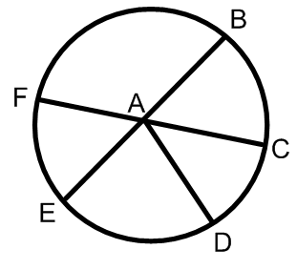

5. What is the value of *x*? 6. What is ? 7. What is ?

Refer to circle A below to answer the following questions (8-10).  and  are tangent to the circle,  is a diameter, and . The figure is not drawn to scale.

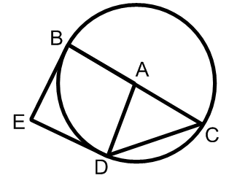

8. What is ? 9. What is ? 10. What is ?

11. Refer to the circle below.

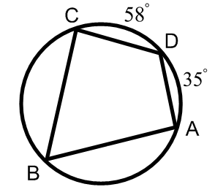

a. What is ? b. What is ?

12.  is a diameter of the circle below. What is ?

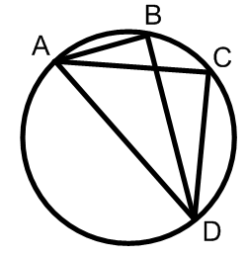

13. What is the equation of the circle with a center of (-9,5) and a radius of 16?

14. Complete the square to find the center and radius of the circle with the equation .

15. Prove or disprove that the point lies on the circle centered at the origin and containing the point (-4,0).

16. A house has the shape and dimentions shown in the figure. What is a model for the volume of the house?

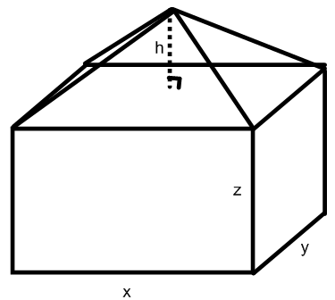

17. Kaybree has an ice cream cone that is 5 inches high and has a diameter of 2.5 inches. If she packs the cone full of ice cream, what is the volume of ice cream in the cone?

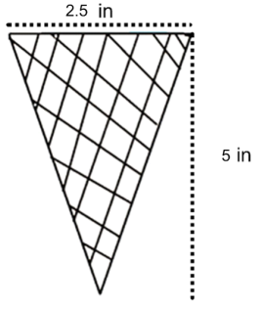

18. What is the **arc length** of a sector that has a radius of 6 ft and a central angle of ?

19. What is the **area of a sector** that has a radius of 6 ft and a central angle of ?

20. What is the equation of the parabola that has a focus of (2,-6) and a directrix of ?

21. The two circles shown are similar. What is the length of *x*?

a. 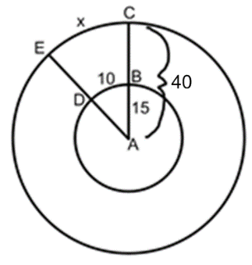 b. 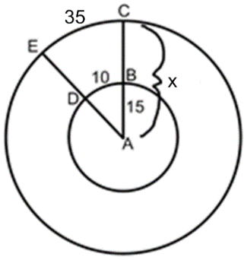

22. Construct a tangent line from the point to the circle.

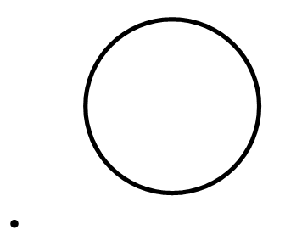

.

23. Construct the inscribed circle of the triangle below.

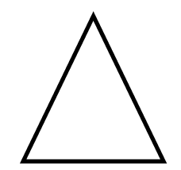

24. Construct the circumscribed circle of the triangle below.

