Two-Way Tables & Probability

**CORE STANDARDS**

HSS.ID.B.5

HSS.CP.A.4

LESSON

**7-2**

OBJECTIVE **1. SWBAT calculate probabilities using two-way tables.**

Anatomy of a Two-Way Table

NOTES

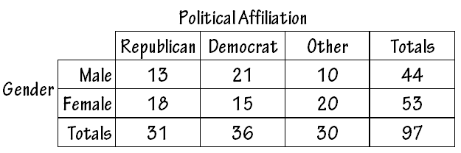

Variable 1

Variable 1 Categories

Variable 2

Variable 2 Categories

Marginal Values (totals)

Frequencies for each cross-category.

e.g., there were 13 individuals who were male republicans.

EXAMPLES

Use the two-way given above to answer the following questions.

**1.** The data in the two-way table above were collected from employees who worked at a certain law firm. How many

employees were surveyed?

**2.** If an employee were selected randomly, find the following probabilities:

a) *P*(male)f) *P*(republican democrat)

b) *P*(democrat) g) *P*(republican democrat)

c) *P*(female republican) h) *P*(otherc)

d) *P*(male other) i) *P*(other | male)

e) *P*(male | democrat) j) *P*(other | male)

**3.** Find the number **31** in the table above. Interpret its meaning in context.

PRACTICE **7-2** NAME______________________________

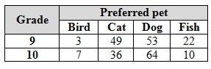 [SHOW YOUR WORK]

1. A survey was performed among a group of high school students. Each student was asked his or her grade level and preferred pet. The two-way frequency table at the right shows the results.
   1. Calculate the marginal values for the chart.
   2. Interpret in context the meaning of the number 22 found in the chart.
   3. If a student from this survey is selected at random, find each probability:
      1. *P*(grade 9) v. *P*(pet fish | grade 9)
      2. *P*(pet cat) vi. *P*(grade 9 | pet fish)
      3. *P*(pet dog grade 10) vii. *P*(pet bird pet fish)
      4. *P*(pet dog grade 10) viii. *P*(pet cat grade 9c)

Preferred Leisure Activity

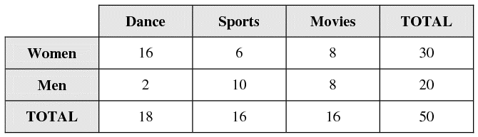

1. Fifty adults were asked which of three leisure activities they preferred. Each person’s gender was also noted and the two-way table at the right was created. If one of the adults from this survey is randomly selected, find the following probabilities:
   1. *P*(man) g) *P*(woman movies)
   2. *P*(sports) h) *P*(woman | dance)
   3. *P*(moviesc) i) *P*(man | dance)
   4. *P*(woman sports) j) *P*(dance sports)
   5. *P*(man dance) k) *P*(dancec manc)
   6. *P*(movies man) l) *P*(womanc movies)



1. Corey was sorting books at the library by fiction and non-fiction and by which age the books were intended for – adult or teen. He forgot the count for teen non-fiction books. Can you fill in the appropriate count if you know that *P*(non-fiction teen) =  for a randomly selected book?