Equations of Circles

**CORE STANDARDS**

HSG.GPE.A.1

LESSON

**6-3**

OBJECTIVE **1. SWBAT write equations of circles in standard form and identify the center and radius.**

Standard Form Equation of a Circle in the Coordinate Plane



Where the length of the radius is *r* and the center is at (*h*, *k*).

NOTES

Example of Converting Polynomial Form of a Circle to Standard Form

Convert to Standard Form: 

1. Rearrange the equation so that like variables are together and the constant is on the right side.



1. Add blanks after each group of like variables with corresponding blanks on the right side.



1. Fill in the blanks to create perfect square trinomials (half the linear coefficient, squared). Add the same to the right side.



1. Write each trinomial as a perfect square; combine all constants on the right side.



**25**

**9**

**25**

**9**

EXAMPLES

**1.** Write the standard form equation of the circle **2.** Identify the center and radius of the circle given

with center at (1, –2) and radius 6. by 

**3.** Write the equation of the circle shown in the graph. **4.** Identify the center and radius of the circle given

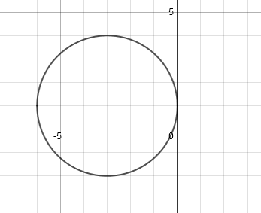 by 

**5.** Graph the circle:  **6.** Find the equation of the circle centered at (7, 10) and

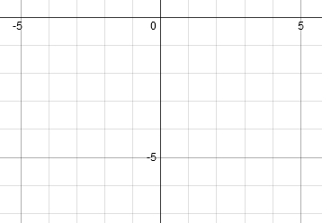 passing through ( –4, 15).

PRACTICE **6-3** NAME______________________________

[SHOW YOUR WORK]

Use the given information to write an equation of each circle in standard form.

1. Center at (4, –8); *r* = 6 2. Center at (–5, 0); *r* = 
2. Center at (2, 7); passing through (5, 3) 4. Center at (–10, 6); passing through (–7, 1)
3. 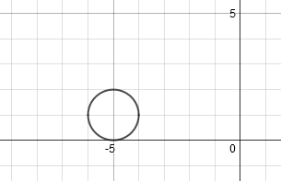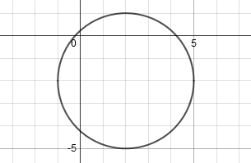 6.

Use each circle's equation to identify its center and radius length.

1.  8. 
2.  10. 
3.  12. 

Graph the circles from problems 3, 8, and 9.

1. 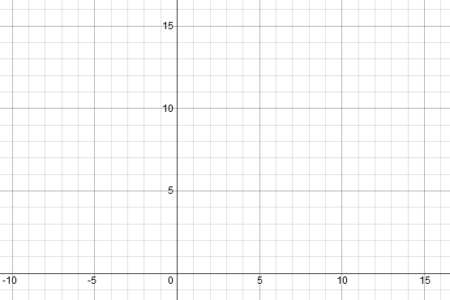 14. Find the coordinates of both

intersections of these circles:



