Solving Right Triangles

**CORE STANDARDS**

HSG.SRT.C.8

LESSON

**5-5**

OBJECTIVE **1. SWBAT use trig ratio definitions to find missing lengths and angles in right triangles.**

Inverse Trig Definitions

Recall from Unit 4 that the word ‘inverse’ means to reverse input and output. For a regular trig function, we input an angle and the output is a ratio. Therefore, for an inverse trig function, we will input a ratio and output an angle. These are especially useful for finding the unknown measure of an angle.

  

NOTES

Trig Ratio

Review







(From Lesson 5-4)

*hyp*

*opp*

*adj*

*θ*

Solving Right Triangles

Given some information about the measures of a triangle, we should be able to find ALL measures of the three sides and three angles. When the measures of all 3 angles and all 3 sides are found, then the triangle is SOLVED.

EXAMPLES

Solve each triangle. Round all answers to the nearest hundredth.

*c*

47

30

*C*

*A*

*B*

*b*

**1.** *a* = **2.** *b* =

= *c* =

*a*

*A*

17

20

*B*

*C*

= =

A wheelchair ramp can be built with a maximum incline of 4.8. If the ramp needs to gain a vertical elevation of 3 feet to reach an entryway, what will be the minimum length of the ramp?

A building is perpendicular to the sidewalk around it. A 20-foot ladder is resting on the sidewalk and is leaning against the building. The foot of the ladder is 5 feet away from the base of the building. What is the measure of the angle formed between the ladder and the sidewalk?

**3.** **4.**

4.8

3’

?

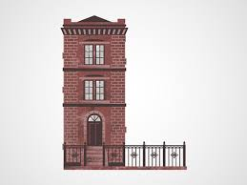

20’

5’

PRACTICE **5-5** NAME______________________________

[SHOW YOUR WORK]

Solve each triangle. Round all answers to the nearest hundredth.

15

*B*

*a*

10

*A*

*C*

64

*B*

*c*

8

*C*

*A*

*b*

1. *b* = 2. *a* =

*c* = =

= =

*B*

*c*

26

7

*A*

*C*

1. *c* = 4. *a* =

*B*

40

*a*

22

*C*

*A*

*b*

= *b* =

= =

*B*

41

*b*

30

*A*

*C*

*B*

75

*c*

34

*A*

*b*

*C*

1. *b* = 6. *b* =

*c* = =

= =

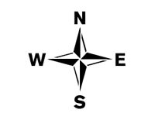

150 mi

220 mi

airport

1. An airplane is flying due north, but has a problem and must make an emergency landing at the nearest airport. The pilot can see on a map that the nearest airport is 150 miles to the east and 220 miles to the north.
   1. How many degrees to the right (of north) should the pilot turn so he will go directly to the airport?
   2. How far away is the airport?
2. The Stratosphere Tower in Las Vegas, Nevada is 1149 feet tall. From where Doug is standing on the streets of Las Vegas, the angle of elevation to the top of the Stratosphere is 81.

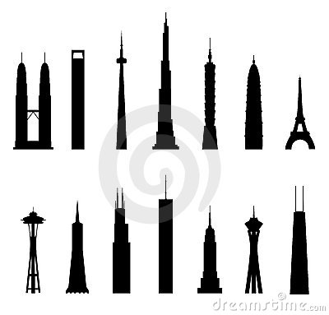

1149 ft

81

* 1. How far away is Doug from the base of the tower?
  2. How far away is Doug from the top of the tower?

*B*

25

*D*

*A*

*C*

1. Given that , as shown, find .