SECONDARY MATH 2

**CORE STANDARDS**

II.2.F.IF.4

II.2.F.IF.6

II.2.F.LE.3

LESSON

**2-4**

OBJECTIVE **1. SWBAT identify features of functions including: classification as odd, even, or neither;**

**and rate of change over a given interval.**

Even Functions

* All degrees of

*x* are even.

* Reflective symmetry

about the *y*-axis.

Odd Functions

* All degrees of

*x* are odd.

* Rotational symmetry

about the origin.

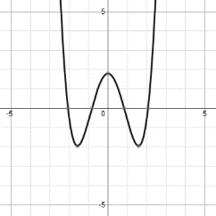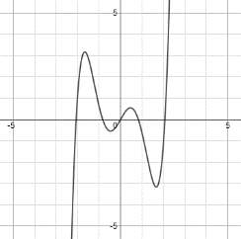NOTES

* If a function does not fit the conditions for either EVEN or ODD, then it is NEITHER even, nor odd.
* A non-zero constant term *c* is considered an even degree of *x*, since it can be written as .

Average Rate of Change:  or  or 

Change in *y* over change in *x*.

(The basic definition)

If you are given a domain interval [*a*, *b*]

If you are given 2 points on the function (*x*1, *y*1) and (*x*2, *y*2)

* The average rate of change of an increasing EXPONENTIAL function will always be GREATER than an increasing QUADRATIC function as .

EXAMPLES

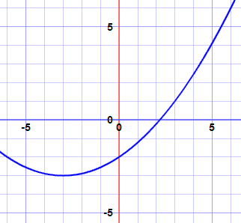

*h*

**1.** For each function, *a*, *b*, *c*, and *d*, find the average rate of change on the interval .



 

**2.** Identify each function as odd, even, or neither.

1.  d) e) f)

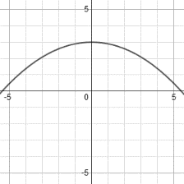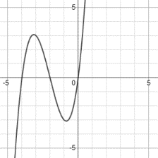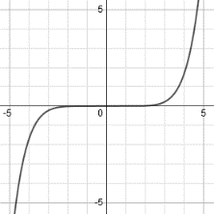

1. 
2. 

PRACTICE **2-4** NAME______________________________

For each given function, find the average rate of change on the indicated intervals.



1. A. [–4, –2] 2. A. [–3, –2]

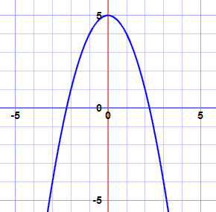

B. [–2, 1] B. [–1, 1]

C. [0, 3] C. [–1, 3]

1.  A. [0, 3] B. [1, 4] C. [–1, 2]
2.  A. [1, 4] B. [3, 8] D. [1, 9]
3. If you were to calculate the average rate of change for each function below on the interval , which would be greatest? Which would be least?

  

Identify each function below as odd, even, or neither.

1.  7.  8. 

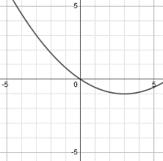

1. 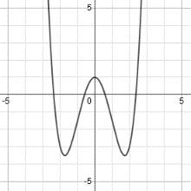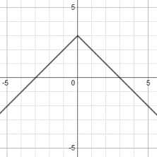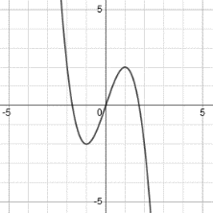 10. 11. 12.
2. Look at  in problem 4. REVIEW 2-2 & 2-3
   1. Describe its transformation compared to 
   2. Identify its vertex and tell whether it’s a maximum or minimum.
3. Does a function exist that is both odd and even? If so, write its equation. If not, explain why it cannot exist.