PRACTICE **2-3** KEY

1. Increasing interval(s):  2. Increasing interval(s): 

Decreasing interval(s):  Decreasing interval(s): NA

Relative maximum(s): NA Relative maximum(s): NA

Relative minimum(s):  Relative minimum(s): NA

*x*-intercept(s):  *x*-intercept(s): 

*y*-intercept:  *y*-intercept: 

1. Increasing interval(s):  4. Increasing interval(s): 

Decreasing interval(s):  Decreasing interval(s): 

Relative maximum(s):  Relative maximum(s): 

Relative minimum(s):  Relative minimum(s): 

*x*-intercept(s):  *x*-intercept(s): 

*y*-intercept:  *y*-intercept: 

1. Increasing interval(s):  6. Increasing interval(s): NA

Decreasing interval(s): NA Decreasing interval(s): 

Relative maximum(s): NA Relative maximum(s): NA

Relative minimum(s): NA Relative minimum(s): NA

*x*-intercept(s):  *x*-intercept(s): 

*y*-intercept:  *y*-intercept: 

1. ; Minimum
2. ; Maximum

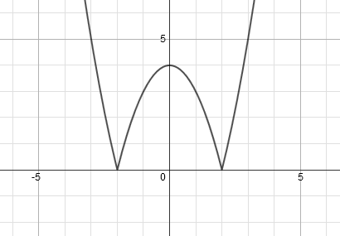

1. ; Maximum
2. ; Minimum
3. 