SECONDARY MATH 2

**CORE STANDARDS**

II.2.F.IF.4

II.2.F.IF.9

LESSON

**2-3**

OBJECTIVE **1. SWBAT identify features of functions including: relative minimum or maximum,**

**intervals of increase or decrease, and *x*- or *y*-intercepts.**

NOTES A function is INCREASING when it travels UP to the right.

(describe using an interval of x-values.)

A function is DECREASING when it travels DOWN to the right.

MAX

A RELATIVE MAXIMUM occurs when a function changes from INCREASING to DECREASING.

(describe using an (x,y) ordered pair)

A RELATIVE MINIMUM occurs when a function changes from DECREASING to INCREASING.

MIN

An X-INTERCEPT is where the function crosses (intersects) the x-axis.

The Y-INTERCEPT is where the function crosses (intersects) the y-axis.

EXAMPLES

For each graph, identify the features listed below. If a feature does not exist for the graph, write NA (not applicable).

**1.** **2. 3.**

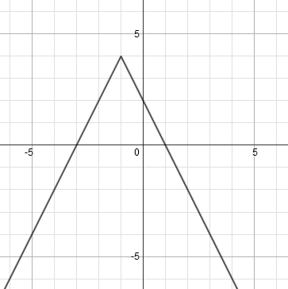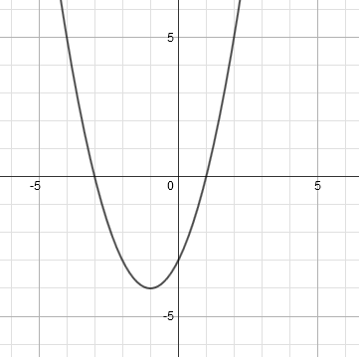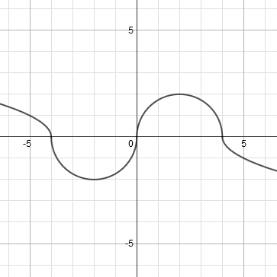

Increasing interval(s) __________

Decreasing interval(s) __________

Relative maximum(s) __________

Relative minimum(s) __________

*x*-intercept(s) __________

*y*-intercept __________

Increasing interval(s) __________

Decreasing interval(s) __________

Relative maximum(s) __________

Relative minimum(s) __________

*x*-intercept(s) __________

*y*-intercept __________

Increasing interval(s) __________

Decreasing interval(s) __________

Relative maximum(s) __________

Relative minimum(s) __________

*x*-intercept(s) __________

*y*-intercept __________

4. For each function, identify the vertex. Tell whether it’s a relative minimum or maximum.

A.  B.  C. 

PRACTICE **2-3** NAME______________________________

For each graph, identify the features listed below. If a feature does not exist for the graph, write NA (not applicable).

1. 2. 3.

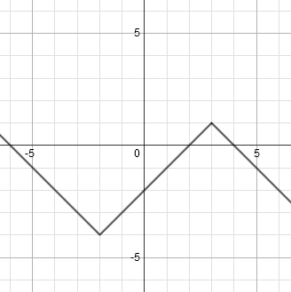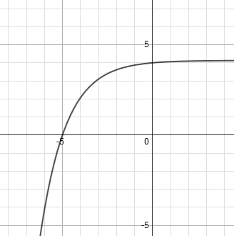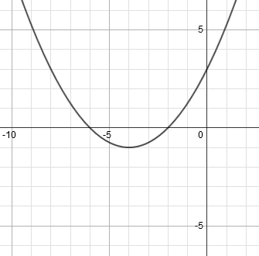

Increasing interval(s) __________

Decreasing interval(s) __________

Relative maximum(s) __________

Relative minimum(s) __________

*x*-intercept(s) __________

*y*-intercept __________

Increasing interval(s) __________

Decreasing interval(s) __________

Relative maximum(s) __________

Relative minimum(s) __________

*x*-intercept(s) __________

*y*-intercept __________

Increasing interval(s) __________

Decreasing interval(s) __________

Relative maximum(s) __________

Relative minimum(s) __________

*x*-intercept(s) __________

*y*-intercept __________

1. 5. 6.

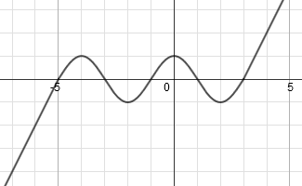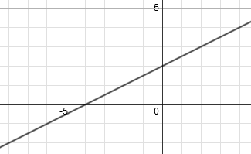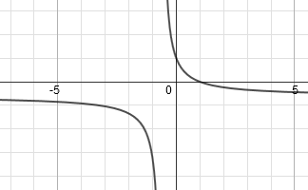

Increasing interval(s) __________

Decreasing interval(s) __________

Relative maximum(s) __________

Relative minimum(s) __________

*x*-intercept(s) __________

*y*-intercept __________

Increasing interval(s) __________

Decreasing interval(s) __________

Relative maximum(s) __________

Relative minimum(s) __________

*x*-intercept(s) __________

*y*-intercept __________

Increasing interval(s) __________

Decreasing interval(s) __________

Relative maximum(s) __________

Relative minimum(s) __________

*x*-intercept(s) __________

*y*-intercept __________

For each function, identify the vertex. Tell whether it’s a relative minimum or maximum.

1.  8. 
2.  10. 
3. Use a graphing utility to find all relative minimums and maximums for: 