PRACTICE **2-1** KEY

1. Quadratic
2. None
3. Absolute value
4. Linear
5. Exponential
6. Linear
7. Exponential
8. Quadratic
9. None
10. Absolute value
11. None
12. Linear
13. Quadratic
14. Exponential
15. Absolute value

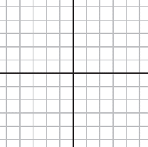

1.  17.



1.  19.



1. Equation for #3: 

Equation for #6: 