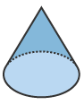
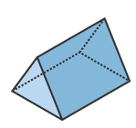
21. Describe the 2 dimensional cross section described from the 3 dimensional shape. Perform this for both shapes.

- Vertical cut through vertex.

- Horizontal cut

- Diagonal cut NOT through base.

Draw the 3 dimensional shape created by rotating the shape as described.
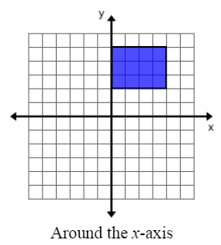
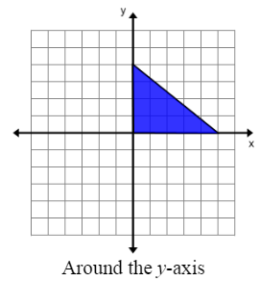

17.

18.

